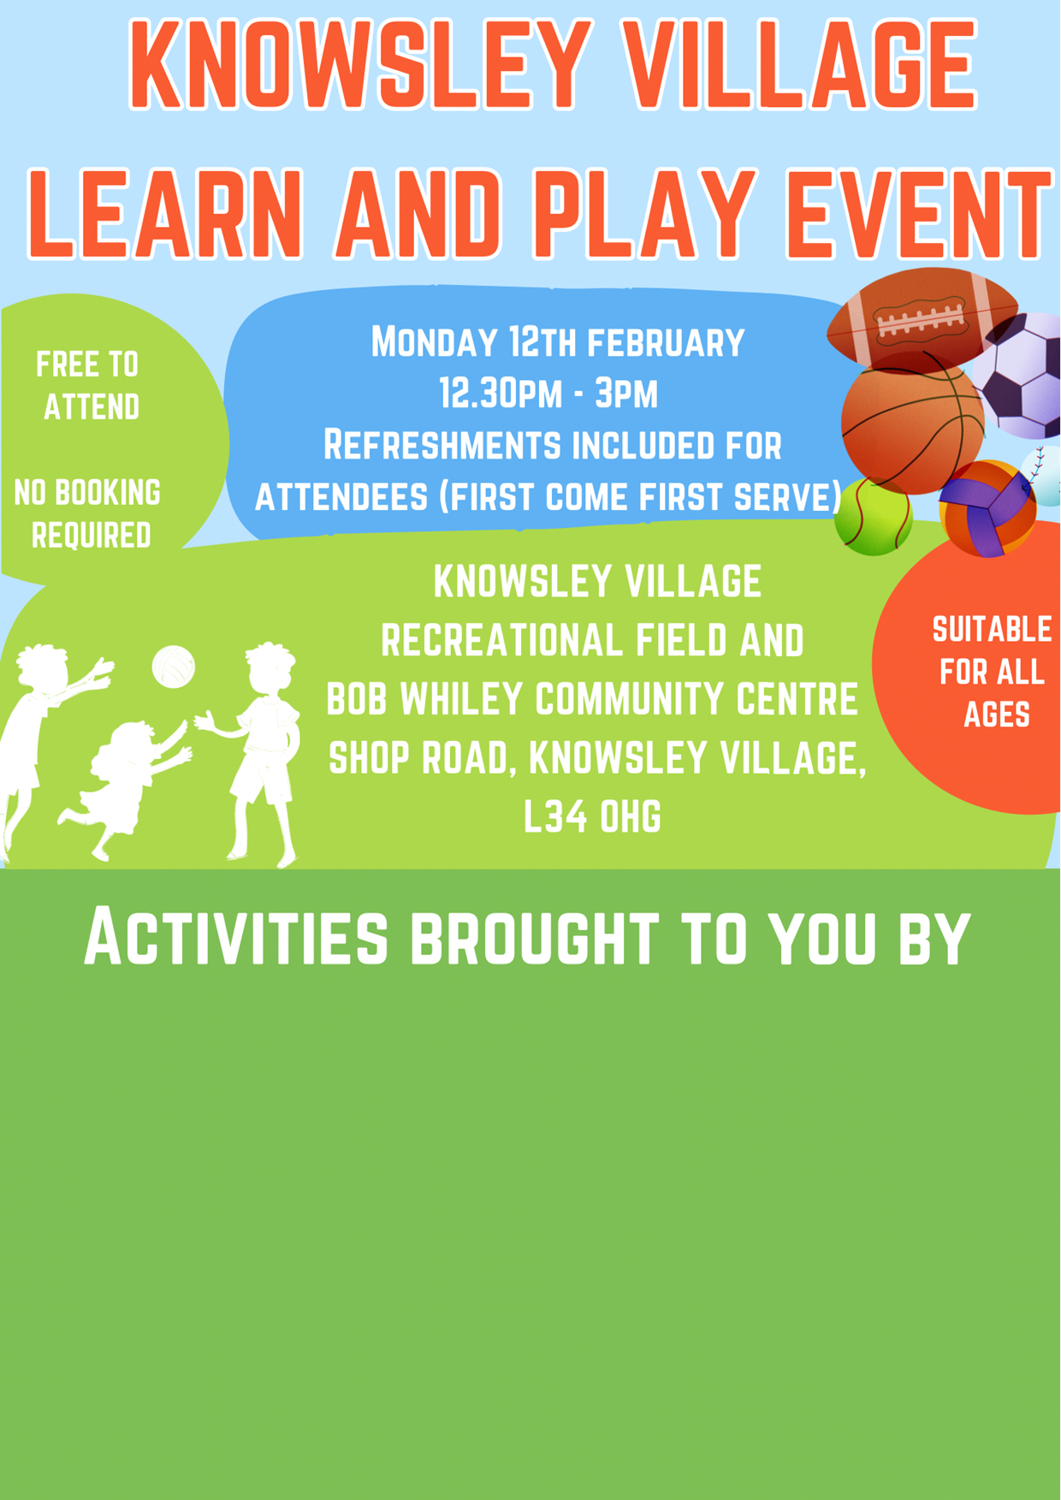

**With thanks to our supporters and sponsors**

